Image Transfer Using GNU Radio and USRP:-
Sudhir Kumar suman - !6D070029 Saarthak Kapse -16D070041 Amit Kumar - 16D070034
The whole process consist of transmittion of a image of any format (Eg. Jpeg ,png ,jpg) from one computer using a USRP and then recieving it in other computer using USRP. The main challenges in this project was clock synchronisation, noise reduction, frequency offset and pahse offset. And main issue we faced was that due to some initial bursting of noise and no clock synchronisation the header of the image file was not getting recieved and thus we were not able to open our recieved file as it has no information which kind of file it is (eg. Jpeg or png or any other). We solved this issue using preamble which is present in packet encoder. Preamble is basically used to give a signal to reciever that a message is coming and thus it is used for a issue of clock synchronisation and because of a long preamble we were able to get header of the image file and thus we were able to open the recieved image file. This project consist of two parts:-
1) Transmition of Image and 2) Recieving Image.
-------------------------------------------------xx-------------------------------------------------
1) Transmition of Image:-

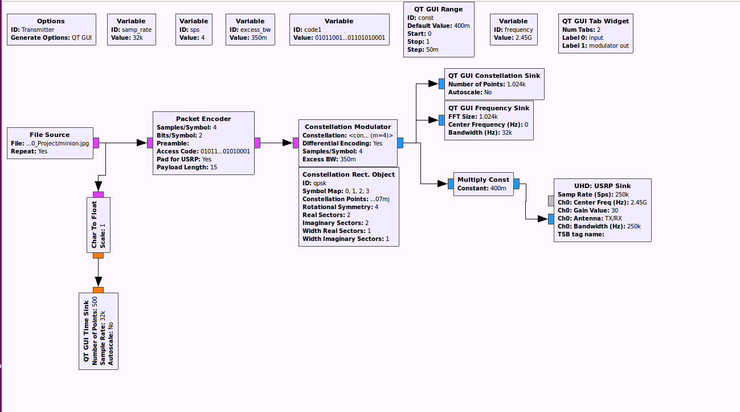

File source block is used for giving the location of the image in our computer that is to be transmitted. It has a attribute repeat which when YES keeps sending image again and again and when NO it stop the process after a image is transmitted once. Then blocks at the bottom of file source block ( Char to Float and QT GUI Time Sink are just used to show the image bits in a voltage level which varies from 0-255 as it is a coloured image and thus every pixel is encoded in 8 bits (basically 2^3) . Then file source output is given in packet encoder. Packet encoder has two three very useful attribute because of which we used it in our project. First one is its encryption of our image using access code attribute, we can set any access code and if same access code is used in recieving part then only we can recieve the image and hence our image is secured and no one else can recieve it. Second one is its preamble which is most important part in our project as it helps us get the header of the transmitted image using clock synchronisation of reciever and transmitter before any transmittion of original image. And preamble can be anything but it should be large number of bits so that it gives transmitter and reciever enough amount of time for clock synchronisation. And in this we are packing 2-2 bits together as we have set bits per symbol to be equal to 2 and payload length is number of symbols per packet, so we use large payload length for sending image. And one thing to note is that preamble is attached with every packet and thus it reduces efficiency and take a long time for sending files, as we were not able to figure out what we should do else we are using this preamble before every packet model only. Then the output of this packet encoder is sent to constellation modulator which is further controlled by constellation object block. In the second path, the signal first passes through a “Constellation Modulator” block. There are several ways to implement PSK in GNU Radio. This was chosen, not only because of the ease of choosing the PSK schemes, but because it implements differential encoding within the block. Differential encoding is the essential thing in Digital Communication as it allows for this unambiguous signal reception. Because of exclusive-or operations on the data, what is transmitted depends, not only on the current bit, but the previous one as well. The Constellation Modulator block is controlled via the Constellation Object block. Any changes in the type of keying being performed, occurs here. For this project, QPSK was used. The output of the Constellation Modulator block is fed to a Constellation Sink to view the Constellation Plot and a Frequency sink for spectral analysis. And finally it is passed through a multiplier which we have integreated with a slider and the output of it is send to USRP Sink which is here used for transmitting of image. And hence transmittion part is completed and next we have described recieving part.
2) Recieving Image
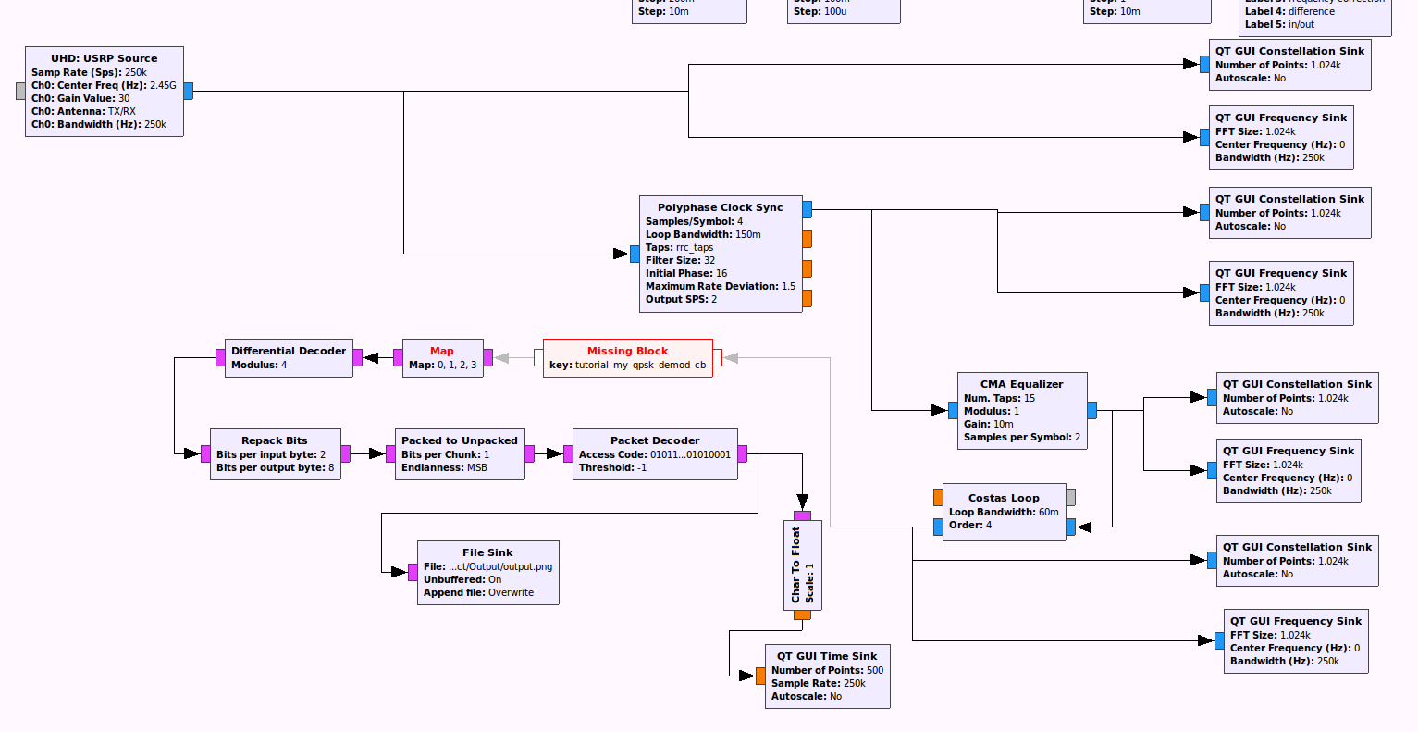

After Receiving the data from USRP , the first issue is to resolve the timing issue between source and sink . The “Poly-phase Clock Sync​” processing block is used to serve this purpose. This block performs multiple tasks. - clock recovery. - Matched filter needed to remove the ISI
Next, a ​ Constant Modulus Algorithm​​ (CMA) equalizer is added to correct multipath distortion. The CMA equalizer will only work on a signal with constant amplitude.it converges the symbols to the unit circle , however it can lock at any given phase and frequency offset and that’s why we have used a ​ Costas Loop​​ to remove frequency and Phase offset.
Then the signal is passed through a ​ QPSK demodulator block ​ after which the symbols are mapped to their binary equivalents .
Since differential encoding was used before modulation at transmitter side , differential decoding is used now as differential symbols were transmitted instead of actual constellation. Since the symbols represent multiple bits, an “Unpack” processing block is used which is further converted into floating point values so that the signal can be viewed on a time plot.

